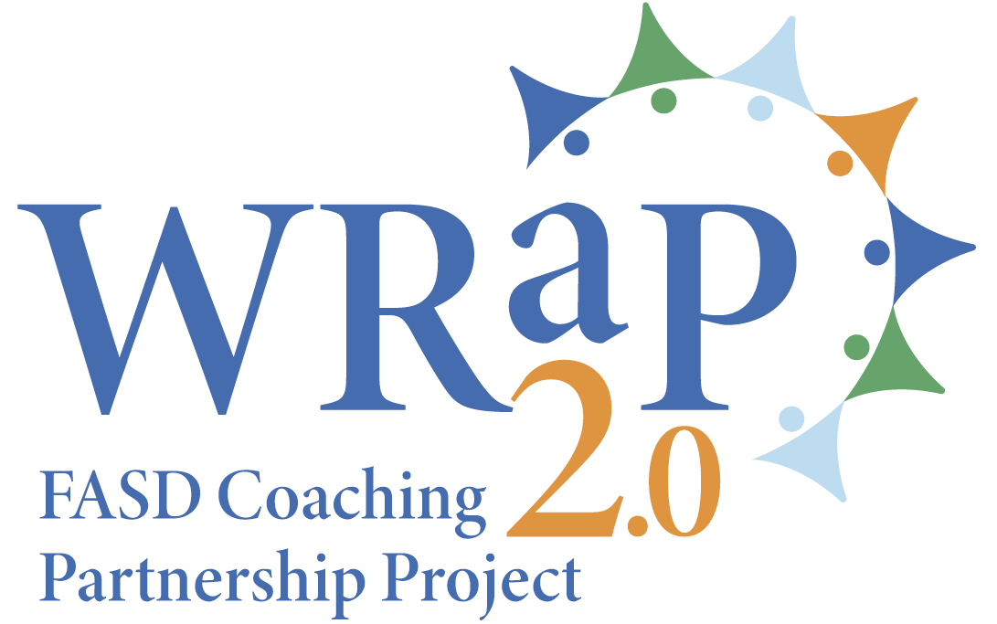 | 2024 WRaP 2.0 Stakeholder Engagement  FASD and Education  Caregivers’ Survey

Alberta FASD Service Networks are made of community agencies and organizations using a holistic, client-focused approach. They work with community partners to provide FASD awareness and prevention, coordinated assessment and diagnosis, and support services that are based on regional and community needs.

The WRaP 2.0 – FASD Coaching Partnership Project is a five-year collaboration (2021-2026) between the Alberta Ministry of Education, Ministry of Seniors, Community and Social Services and the Networks. Since 2022, 10 regional FASD Instructional Coach positions have facilitated professional development, shared FASD resources and strategies, and provided small group or one-on-one FASD-informed support to educators.

We are seeking feedback from Alberta educators about the impact of the WRaP 2.0 project, and the planning of future engagement, partnership, or collaboration between the education sector and FASD Service Networks.

Your participation in this survey is voluntary, and you may withdraw at any time.
Information will be housed with the Edmonton Fetal Alcohol Network. All data is stored in a password protected electronic format. Aggregate (non-identifying) data will be shared with Alberta FASD Service Networks and project stakeholders.

If you have any questions about the survey, please contact Lisa Rogozinsky, Network Coordinator, Edmonton Fetal Alcohol Network at 780-919-0224 or lisa@rogozinsky.org

Electronic consent
Clicking on the “Agree” button below indicates that:
You have read the above information.
You voluntarily agree to participate in the survey.
You are or have been an employee of a school or school division in Alberta
If you do not wish to participate in the survey, please decline participation by selecting the “disagree” option.

- Do you agree to participate in this survey? | Agree |  | Disagree

If you agree, please go to question 2. If you disagree, thank you for taking the time to consider taking this survey.

- Thinking about the school experience of your child/children with/possibly with FASD, how would you rate your child/children’s educators? (teachers, educational assistants, management, etc.)? | Very poor | Poor | Acceptable | Good | Very good | Don’t know
Educators’ knowledge of FASD
Educators’ knowledge of FASD-informed classroom and instructional strategies
Educators‘ ability to incorporate FASD-informed strategies into the classroom
Educators’ ability to create and implement FASD-informed individualized learning plans
Educators’ ability to develop and support transition plans for students with/possible with FASD
Educators’ ability to establish, promote and sustain FASD-informed inclusive learning environments

- To your knowledge, did the educators of your children ever interact with one of the WRaP 2.0 FASD instructional coaches? | Yes |  | No |  | Don’t remember

If you selected “yes”, please go to question 4. If you selected “no” or “don’t’ remember”, please go to question 6.

- If yes, in which way(s) did the WRaP 2.0 FASD instructional coach interact with your child/children’s educators and schools? Please check all that applies.
The WRaP 2.0 FASD instructional coach shared information and resources about FASD with the school/educators.
The WRaP 2.0 FASD instructional coach facilitated a professional development session for the school/educators.
The WRaP 2.0 FASD instructional coach engaged with educators during the FASD assessment and diagnosis process of my child/children.
The WRaP 2.0 FASD instructional coach advised on FASD-informed classroom and teaching strategies.
The WRaP 2.0 FASD instructional coach participated in a school consultation regarding my child/children.

- Overall, how satisfied are you with the support provided by the WRaP 2.0 FASD instructional coach? | Very satisfied |  | Satisfied |  | Neither satisfied nor dissatisfied |  | Dissatisfied |  | Very dissatisfied

- To you knowledge, did the educators of your child/children with/possibly with FASD interact with other FASD service providers since 2022? | Yes |  | No |  | I don’t know

If you selected “yes”, please go to question 7. If you selected “no” or “I don’t’ know”, please go to question 9.

- If yes, in which way(s) did other FASD service providers interact with your child/children’s educators and schools? Please check all that applies.
FASD service providers shared information and resources about FASD with the school/educators.
FASD service providers facilitated a professional development session for the school/educators.
FASD service providers engaged with educators during the FASD assessment and diagnosis process of my child/children.
FASD service providers advised on FASD-informed classroom and teaching strategies.
FASD service providers participated in a school consultation regarding my child/children.

- Overall, how satisfied are you with the support provided by other FASD service providers? | Very satisfied |  | Satisfied |  | Neither satisfied nor dissatisfied |  | Dissatisfied |  | Very dissatisfied

- Please use this section to describe your child/children with/possibly with FASD's experience with the education sector. Did you notice any change in their behaviour and/or steps taken to improved academic performances because of the support provided by your FASD Network, a WRaP 2.0 FASD instructional coach, or a community FASD service provider. (Please don't include any identifying information.)

- Please use this section to comment on the challenges/roadblocks you experienced when seeking the assistance from an FASD Network, a WRaP 2.0 FASD instructional coach, or a FASD service provider, to help you and your child/children with/possibly with FASD regarding school-related concerns.

- Please use this section for suggestions you may have regarding enhanced partnership or collaboration between schools and FASD Networks or community FASD service providers.

- Which grades do you child/children with/possibly with FASD currently attend? Please select all that applies
Early childhood services and Kindergarten |  | Grades 7 to 9
Grades 1 to 6 |  | Grades 10 to 12

- Please identify the community closest to your school(s)/place(s) of work
Grande Prairie, High Prairie, Fox Creek, Peace River, Grande Cache and area
Fort McMurray and area
High Level and area
Edson, Hinton, Slave Lake, Westlock, Athabasca and area
Cold Lake, Bonnyville, St Paul, Lac la Biche and area
Camrose, Drayton Valley, Provost, Lamont, Lloydminster and area
Edmonton and area
Red Deer, Rocky Mountain House and area
Calgary, Wheatland County, Willow Creek MD, Rockyview MD, Chestemere, Claresholm and area
Lethbridge, Taber, Fort Macleod, Cardston and area
Medicine Hat, Brooks, Dunmore and area

- Is your school(s)/place(s) of work on a First Nations Reserve or a Métis Settlement?
Yes |  | No
If yes, which one?

Thank you for taking the time to complete this survey. We appreciate your feedback.

