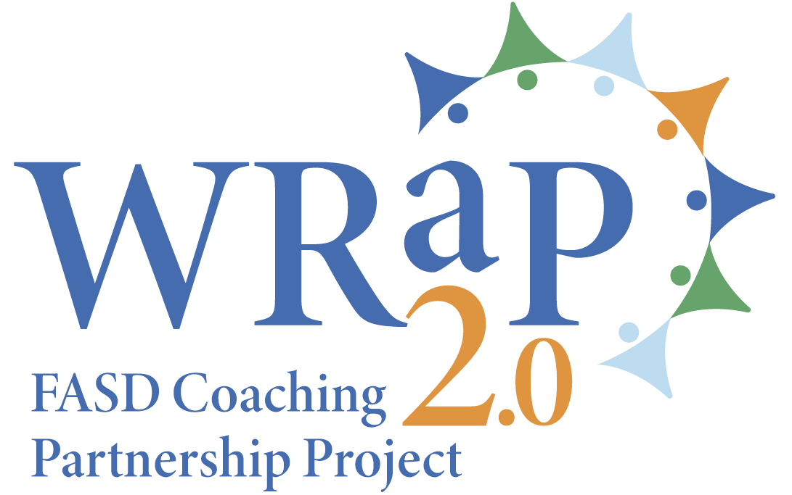 | 2024 WRaP 2.0 Stakeholder Engagement  FASD and Education  Network Coordinators’ Interviews

Date of interview
Network
Names of positions of respondents

- What changes did your Network experience regarding interactions with schools/school authorities and educators, because of the WRaP 2.0 project? Has having an FASD instructional coach enhanced your interactions with educators, schools and school divisions?

- To what extent has the WRaP 2.0 project allowed your Network to increase your reach to educators in your target area? Have you experienced any changes in the openness of the education sector in your region regarding FASD, because of WRaP 2.0?

- How has the WRaP 2.0 project impacted other FASD services in your area (awareness and prevention, assessment and diagnosis, outreach/support, Prevention Conversation)?

- Please share a story on how the WRaP 2.0 project has contributed to a more positive school experience or better academic results for a student supported by your Network.

- Did your Network face any challenges or barriers in implementing the WRaP 2.0 project? If yes, what were they, and how did you overcome them?

- The Government of Alberta has not given any indication yet on the future of the WRaP 2.0 project beyond January 2026. What are your thoughts regarding future partnership between Networks and the education system?

- Do you have any other thoughts or comments, regarding the WRaP 2.0 project?

