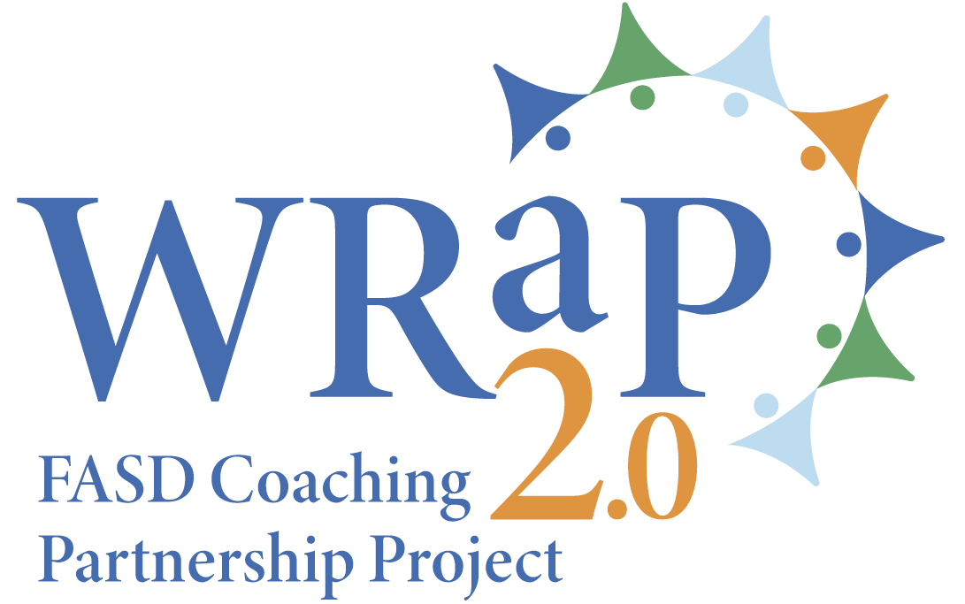 | 2024 WRaP 2.0 Stakeholder Engagement  FASD and Education  Educators’ Survey

Alberta FASD Service Networks are made of community agencies and organizations using a holistic, client-focused approach. They work with community partners to provide FASD awareness and prevention, coordinated assessment and diagnosis, and support services that are based on regional and community needs.

The WRaP 2.0 – FASD Coaching Partnership Project is a five-year collaboration (2021-2026) between the Alberta Ministry of Education, Ministry of Seniors, Community and Social Services and the Networks. Since 2022, 10 regional FASD Instructional Coach positions have facilitated professional development, shared FASD resources and strategies, and provided small group or one-on-one FASD-informed support to educators.

We are seeking feedback from Alberta educators about the impact of the WRaP 2.0 project, and the planning of future engagement, partnership, or collaboration between the education sector and FASD Service Networks.

Your participation in this survey is voluntary, and you may withdraw at any time.
Information will be housed with the Edmonton Fetal Alcohol Network. All data is stored in a password protected electronic format. Aggregate (non-identifying) data will be shared with Alberta FASD Service Networks and project stakeholders.

If you have any questions about the survey, please contact Lisa Rogozinsky, Network Coordinator, Edmonton Fetal Alcohol Network at 780-919-0224 or lisa@rogozinsky.org

Electronic consent
Clicking on the “Agree” button below indicates that:
You have read the above information.
You voluntarily agree to participate in the survey.
You are or have been an employee of a school or school division in Alberta
If you do not wish to participate in the survey, please decline participation by selecting the “disagree” option.

- Do you agree to participate in this survey? | Agree |  | Disagree

If you agree, please go to question 2. If you disagree, thank you for taking the time to consider taking this survey.

- Thinking about your own knowledge, skills and expertise, please rate yourself in the following areas. | Very poor | Poor | Acceptable | Good | Very good | Don’t know
Your knowledge of FASD

Your knowledge of FASD-informed classroom and instructional strategies
Your ability to incorporate FASD-informed strategies into the classroom
Your ability to create and implement FASD-informed individualized learning plans
Your ability to develop and support transition plans for students with/possible with FASD
Your ability to establish, promote and sustain FASD-informed inclusive learning environments

- Thinking about your school(s)/place(s) of work knowledge, skills and expertise, please rate them in the following areas. | Very poor | Poor | Acceptable | Good | Very good | Don’t know
Your school(s)/place(s) of work knowledge of FASD

Your school(s)/place(s) of work knowledge of FASD-informed classroom and instructional strategies
Your school(s)/place(s) of work ability to incorporate FASD-informed strategies into the classroom
Your school(s)/place(s) of work ability to create and implement FASD-informed individualized learning plans
Your school(s)/place(s) of work ability to develop and support transition plans for students with/possible with FASD
Your school(s)/place(s) of work ability to establish, promote and sustain FASD-informed inclusive learning environments

- Have you ever interacted with one of the WRaP 2.0 FASD instructional coaches? | Yes |  | No |  | Don’t remember

If you selected “yes”, please go to question 5. If you selected “no” or “don’t’ remember”, please go to question 8.

- If yes, how did you interact with the WRaP 2.0 FASD instructional coach? Please check all that applies.
The WRaP 2.0 FASD instructional coach facilitated a professional development session on FASD and FASD-informed strategies.
The WRaP 2.0 FASD instructional coach shared information and resources about FASD and FASD-informed strategies.
The WRaP 2.0 FASD instructional coach participated in a case consultation or a meeting regarding a student with/possibly with FASD.
The WRaP 2.0 FASD instructional coach provided FASD-informed classroom learning support.
The WRaP 2.0 FASD instructional coach did a classroom observation.
The WRaP 2.0 FASD instructional coach offered at-the-elbow support.
The WRaP 2.0 FASD instructional coach helped with community connections for students with/possibly with FASD.

- Please rate the WRaP 2.0 FASD instructional coach in the following areas | Very poor | Poor | Acceptable | Good | Very good | Don’t know
The WRaP 2.0 FASD instructional coach’s knowledge and understanding of the school environment
The WRaP 2.0 FASD instructional coach’s knowledge and understanding of FASD-informed classroom and teaching strategies
The WRaP 2.0 FASD instructional coach’s knowledge and understanding of FASD-informed individualized learning plans
The WRaP 2.0 FASD instructional coach’s ability to support you and your school(s)/place(s) or work with FASD-related issues

- How satisfied are you with the support you and your school(s) /place(s) of work received from the WRaP 2.0 FASD instructional coach? | Very satisfied |  | Satisfied |  | Neither satisfied nor dissatisfied |  | Dissatisfied |  | Very dissatisfied

- Have you ever interacted with other FASD service providers in your region since 2022 | Yes |  | No |  | Don’t remember

If you selected “yes”, please go to question 9. If you selected “no” or “don’t’ remember”, please go to question 16.

- If yes, how did you interact with other FASD service provider(s)? Please check all that applies.
FASD service providers facilitated a professional development session on FASD and FASD-informed strategies.
FASD service providers shared information and resources about FASD and FASD-informed strategies.
FASD service providers participated in a case consultation or a meeting regarding a student with/possibly with FASD.
FASD service providers provided FASD-informed classroom learning support.
FASD service providers did a classroom observation.
FASD service providers offered at-the-elbow support.
FASD service providers helped with community connections for students with/possibly with FASD.

- Please rate the other FASD service provider(s) in the following areas | Very poor | Poor | Acceptable | Good | Very good | Don’t know
Other FASD service provider(s)’ knowledge and understanding of the school environment
Other FASD service provider(s)’ knowledge and understanding of FASD-informed classroom and teaching strategies
Other FASD service provider(s)’ knowledge and understanding of FASD-informed individualized learning plans
Other FASD service provider(s)’ ability to support you and your school(s)/place(s) or work with FASD-related issues

- How satisfied are you with the support you and your school(s) /places of work received from other FASD service provider(s)? | Very satisfied |  | Satisfied |  | Neither satisfied nor dissatisfied |  | Dissatisfied |  | Very dissatisfied

- Please use this section to describe steps taken to improve practice in your classroom and/or at your school(s)/place(s) of work because of the support received from the WRaP 2.0 FASD instructional coach and/or other FASD service providers.

- Please share an example on how the WRaP 2.0 FASD instructional coach and/or other FASD service providers have contributed to making a difference in your classroom or your teaching style.

- Please share a story on how the WRaP 2.0 FASD instructional coach and/or other FASD service providers have contributed to a more positive school experience and/or steps taken to improved academic results for one of your students with/possibly with FASD. (Do not including any names or identifying information!)

- Please use this section to comment on the challenges/roadblocks you and your school(s)/place(s) of work experienced in interacting with the WRaP 2.0 FASD instructional coach and/or other FASD service providers over the last 2 years, and how you overcame them.

- Please use this section for suggestions you may have regarding enhanced partnerships or collaborations between schools, caregivers, and FASD Service Networks and/or FASD service providers.

- What best describes you?
Teacher |  | Member of school leadership or administration
Member of an education support team |  | Other (please specify)

- Please identify the community closest to your school(s)/place(s) of work
Grande Prairie, High Prairie, Fox Creek, Peace River, Grande Cache and area
Fort McMurray and area
High Level and area
Edson, Hinton, Slave Lake, Westlock, Athabasca and area
Cold Lake, Bonnyville, St Paul, Lac la Biche and area
Camrose, Drayton Valley, Provost, Lamont, Lloydminster and area
Edmonton and area
Red Deer, Rocky Mountain House and area
Calgary, Wheatland County, Willow Creek MD, Rockyview MD, Chestemere, Claresholm and area
Lethbridge, Taber, Fort Macleod, Cardston and area
Medicine Hat, Brooks, Dunmore and area

- Is your school(s)/place(s) of work on a First Nations Reserve or a Métis Settlement?
Yes |  | No
If yes, which one?

Thank you for taking the time to complete this survey. We appreciate your feedback.

